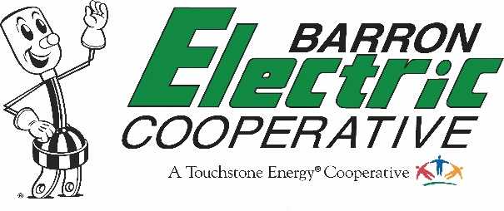
1434 State Highway 25 North • PO Box 40 • Barron, WI 54812
Phone: 800-322-1008 • Fax: 715-637-1906 • For Outages Only: 866-258-8722

For Immediate Release
Contact Person: Carrie Baribeau, Communication Specialist
March 1, 2023
Participation Powers Progress is the Theme of
Barron Electric Cooperative’s 87th Annual Meeting

Join us at Barron Electric Cooperative’s 87th Annual Meeting on Saturday, March 25 at the Barron High School in Barron. Registration will start at 8 a.m. with a free breakfast served by the Barron VFW. Members should bring their March electric bill statement to the annual meeting, which includes a barcode to register for the meeting or take a picture of the barcode. Members can also access their bill statement through SmartHub on their mobile device.

Learn how “Participation Powers Progress” at the business meeting, which will begin at 10 a.m. Ron Franz, Director of Resource and Energy Planning at Dairyland Power Cooperative, will be the guest speaker and will highlight clean energy. Director elections will be held for Districts 2, 4, and 8. Please view our March newsletter online at barronelectric.com (news center) for more important annual meeting information.

Members will have the opportunity to win one of twelve $100 cash prizes. Each member, one per membership, will receive an umbrella. All attendees will receive a pound of cheese. Help support our local communities by bringing a non-perishable food item for the Cameron Food Pantry to help support those in need.

The Kids’ Program has been eliminated due to low attendance during the past few years. We apologize for any inconvenience.

**********

Barron Electric Cooperative is an Equal Opportunity Provider and Employer.

